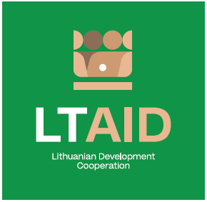
development cooperation PROJECT CONCEPT NO 1

“Digital Transformation in nigeria, kenya and ghana”

GENERAL INFORMATION ON THE PROJECT
1. Partner country (-ies) | Nigeria, Kenya, Ghana*
2. Area(s) of cooperation | Digitalization
3. Project description
3.1. Project aim | To help develop a faster market transition to modern digital economy solutions in Nigeria, Kenya and Ghana. To contribute to the implementation of the goals of the EU initiative D4D (Digital for Development Hub) platform, of which Lithuania is one of the founders
3.2. Project objectives | 1. To propose and implement digital solutions in Nigeria (priority would be given to the area of data protection regulation);  2. To promote digital entrepreneurship and innovation in Kenya (priority would be given to the areas of smart agriculture and commerce);  3. To contribute to the development of digital economy in Ghana (priority would be given to the area of e-payments).
3.3. Target group(s) | Public and private sectors in Nigeria, Kenya and Ghana
4. Estimated duration of project implementation | Up to 12 months, if the total cost of the project is less than 50.000 EUR.  Up to 24 months, if the total cost of the project is more than 50.000 EUR.
5. Additional information  Where available, indicate additional evaluation criteria** for project applications to be drawn up according to this project concept, or other information important to applicants. | - Experience in implementing projects of a similar nature;  - Financial contribution of applicant and / or other additional sources of financing.

*Please select no less than two countries mentioned
**According to Paragraph 35 of the Description of the Procedure for the Implementation of Development Cooperation and Humanitarian Aid Activities by State and Municipal Institutions and Agencies approved by Resolution No 278 of the Government of the Republic of Lithuania dated 26 March 2014, an application can be assigned additional scores for compliance with the additional project application evaluation criteria indicated in the institution’s call. The additional criteria may be provided for if a specific development cooperation activity is planned in the call or if specific abilities or experience are expected from the applicants

