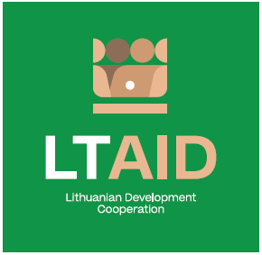
DEVELOPMENT COOPERATION PROJECT CONCEPT NO 10

“SUPPORT FOR UKRAINIAN CITIZENS suffering FROM THE WAR IN UKRAINE”

GENERAL INFORMATION ON THE PROJECT
1. Partner country (-ies) | Ukraine
2. Area(s) of cooperation | Support for internally displaced persons
3. Project description
3.1. Project aim | To provide support for the improvement of the social and economic situation of internally displaced persons in Ukraine.
3.2. Project objectives | 1. To contribute to the social and economic integration of internally displaced persons in local communities (to help Ukrainians to acquire the necessary competences and skills in order to increase opportunities for employment or creating a business).  2. To encourage the development of added value and export capabilities of small and medium size businesses of internally displaced persons.  3. To support education and non-formal education initiatives of forcibly displaced children.  4. To organize the provision of psychological assistance to internally displaced persons affected by the war.
3.3. Target group(s) | Internally displaced persons
4. Estimated duration of project implementation | Up to 12 months, if the total cost of the project is less than 50.000 EUR.  Up to 24 months, if the total cost of the project is more than 50.000 EUR.
5. Additional information  Where available, indicate additional evaluation criteria* for project applications to be drawn up according to this project concept, or other information important to applicants. | - Experience in implementing projects of a similar nature;  - Experience of cooperation with partners in Ukraine;  - Financial contribution of applicant and / or other additional sources of financing;  - The project will be considered suitable if it meets at least one objective.
*According to Paragraph 35 of the Description of the Procedure for the Implementation of Development Cooperation and Humanitarian Aid Activities by State and Municipal Institutions and Agencies approved by Resolution No 278 of the Government of the Republic of Lithuania dated 26 March 2014, an application can be assigned additional scores for compliance with the additional project application evaluation criteria indicated in the institution’s call. The additional criteria may be provided for if a specific development cooperation activity is planned in the call or if specific abilities or experience are expected from the applicants.

