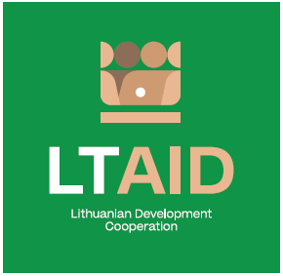
DEVELOPMENT COOPERATION PROJECT CONCEPT NO 11

“SUPPORT FOR THE STRENGTHENING OF UZBEKISTAN'S EDUCATION SYSTEM IN THE FIELD OF DIGITALIZATION”

GENERAL INFORMATION ON THE PROJECT
1. Partner country (-ies) | Uzbekistan
2. Area(s) of cooperation | Education
3. Project description
3.1. Project aim | To support Uzbekistan in implementing information technologies in the field of education; to contribute to the implementation of the "Digital Uzbekistan 2030" initiative.
3.2. Project objectives | 1. To participate in the implementation of various digitization programs of the educational system in Uzbekistan by implementing electronic diaries and education registers, improving distance learning, as well as creating and carrying out other digitization programs in the field of education.  2. To improve digital skills of women and youth.  3. To create a positive image of Lithuania by strengthening the cooperation between Lithuanian and Uzbek educational, research and academic institutions.
3.3. Target group(s) | Educational, scientific and academic institutions of Uzbekistan
4. Estimated duration of project implementation | Up to 12 months, if the total cost of the project is less than 50.000 EUR.  Up to 24 months, if the total cost of the project is more than 50.000 EUR.
5. Additional information  Where available, indicate additional evaluation criteria* for project applications to be drawn up according to this project concept, or other information important to applicants. | - Experience in implementing projects of a similar nature;  - Financial contribution of applicant and / or other additional sources of financing.

*According to Paragraph 35 of the Description of the Procedure for the Implementation of Development Cooperation and Humanitarian Aid Activities by State and Municipal Institutions and Agencies approved by Resolution No 278 of the Government of the Republic of Lithuania dated 26 March 2014, an application can be assigned additional scores for compliance with the additional project application evaluation criteria indicated in the institution’s call. The additional criteria may be provided for if a specific development cooperation activity is planned in the call or if specific abilities or experience are expected from the applicants.

