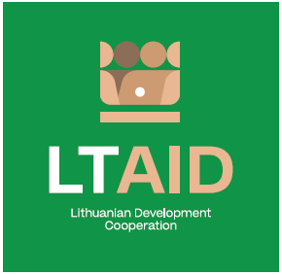
development cooperation PROJECT CONCEPT NO 2

“SUpport for the strengthening of Armenia’s administrative and institutional capacity”

GENERAL INFORMATION ON THE PROJECT
1. Partner country (-ies) | Republic of Armenia
2. Area(s) of cooperation | Good governance
3. Project description
3.1. Project aim | To contribute to the strengthening of Armenia’s administrative and institutional capacity and governance through the implementation of reforms envisaged under the Armenia-EU Comprehensive and Enhanced Partnership Agreement (CEPA).
3.2. Project objectives | 1. To transfer Lithuania's experience in the field of public sector reform and optimize Armenia’s public sector, bringing it closer to EU standards.  2. To provide expert support for reforms enabling the rule of law (modernization of justice, police, customs, civil service systems, consumer rights protection, etc.)  3. To transfer the good practice and experience of Lithuania in the fields of public service (digitalization, health care, etc.), which correspond to Armenia’s reforms priorities.
3.3. Target group(s) | Armenian state institutions
4. Estimated duration of project implementation | Up to 12 months, if the total cost of the project is less than 50.000 EUR.  Up to 24 months, if the total cost of the project is more than 50.000 EUR.
5. Additional information  Where available, indicate additional evaluation criteria* for project applications to be drawn up according to this project concept, or other information important to applicants. | - The project implementer must be a public administration entity;  - Experience in implementing similar projects with public institutions in Eastern Partnership countries;  - Financial contribution of applicant and / or other additional sources of financing.
*According to Paragraph 35 of the Description of the Procedure for the Implementation of Development Cooperation and Humanitarian Aid Activities by State and Municipal Institutions and Agencies approved by Resolution No 278 of the Government of the Republic of Lithuania dated 26 March 2014, an application can be assigned additional scores for compliance with the additional project application evaluation criteria indicated in the institution’s call. The additional criteria may be provided for if a specific development cooperation activity is planned in the call or if specific abilities or experience are expected from the applicants

