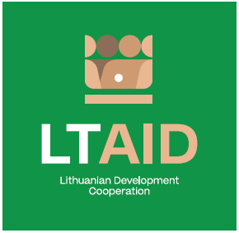
development COOPERATION PROJECT CONCEPT no 3

“DEVELOPMENT OF A CLEAN ENVIRONMENT IN ARMENIA THROUGH THE DEVELOPMENT A SUSTAINABLE WASTE SORTING SYSTEM (II)”

GENERAL INFORMATION ON THE PROJECT
1. Partner country (-ies) | Republic of Armenia
2. Area(s) of cooperation | Environment protection
3. Project description
3.1. Project aim | To support in developing a sustainable management system for glass and plastic waste in Armenia
3.2. Project objectives | 1. To support in the development of legal regulatory reform in the field of waste management in line with EU-Armenia Comprehensive and Enhanced Partnership Agreement (CEPA) commitments;  2. To continue expert support focusing on the creation of a legal framework for the regulation of the Extended Producer Responsibility system in Armenia, which enables the introduction of a deposit system;  3. To increase the awareness of Armenians in the field of waste management, and to continue informing the public about the benefits of sustainable management of glass and plastic waste.
3.3. Target group(s) | State institutions of the environmental protection sector of Armenia
4. Estimated duration of project implementation | Up to 12 months, if the total cost of the project is less than 50.000 EUR.  Up to 24 months, if the total cost of the project is more than 50.000 EUR.
5. Additional information  Where available, indicate additional evaluation criteria* for project applications to be drawn up according to this project concept, or other information important to applicants. | - Experience in implementing projects of a similar nature;  - Financial contribution of applicant and / or other additional sources of financing.
*According to Paragraph 35 of the Description of the Procedure for the Implementation of Development Cooperation and Humanitarian Aid Activities by State and Municipal Institutions and Agencies approved by Resolution No 278 of the Government of the Republic of Lithuania dated 26 March 2014, an application can be assigned additional scores for compliance with the additional project application evaluation criteria indicated in the institution’s call. The additional criteria may be provided for if a specific development cooperation activity is planned in the call or if specific abilities or experience are expected from the applicants.

