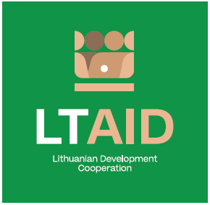
DEVELOPMENT COOPERATION PROJECT CONCEPT NO 5

“SUPPORT FOR CIVIC EDUCATION OF BELARUSIANS”

GENERAL INFORMATION ON THE PROJECT
1. Partner country (-ies) | Belarus
2. Area(s) of cooperation | Democracy and civil society
3. Project description
3.1. Project aim | To contribute to the civic education of Belarusians who were forced to leave Belarus; to strengthen their Belarusian and European identity.
3.2. Project objectives | 1. To encourage the use of the Belarusian language by developing language courses and promoting other activities which foster the national identity of Belarusians;  2. To strengthen citizenship skills of Belarusians and to promote various civic initiatives.
3.3. Target group(s) | People from Belarus, especially youth.
4. Estimated duration of project implementation | Up to 12 months, if the total cost of the project is less than 50.000 EUR.  Up to 24 months, if the total cost of the project is more than 50.000 EUR.
5. Additional information  Where available, indicate additional evaluation criteria** for project applications to be drawn up according to this project concept, or other information important to applicants. | - Experience in implementing projects of a similar nature;  - Experience and knowledge of the political situation in Belarus;  - Financial contribution of applicant and / or other additional sources of financing.

*According to Paragraph 35 of the Description of the Procedure for the Implementation of Development Cooperation and Humanitarian Aid Activities by State and Municipal Institutions and Agencies approved by Resolution No 278 of the Government of the Republic of Lithuania dated 26 March 2014, an application can be assigned additional scores for compliance with the additional project application evaluation criteria indicated in the institution’s call. The additional criteria may be provided for if a specific development cooperation activity is planned in the call or if specific abilities or experience are expected from the applicants.

