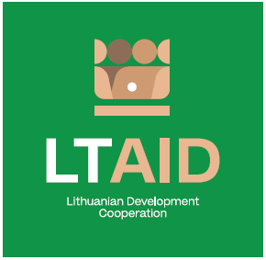
DEVELOPMENT COOPERATION PROJECT CONCEPT NO 6
“Economic and social empowerment of iraqi youth”
GENERAL INFORMATION ON THE PROJECT
1. Partner country (-ies) | Iraq
2. Area(s) of cooperation | Economic and social empowerment
3. Project description
3.1. Project aim | To create professional employment opportunities for Iraqi youth which would contribute to the improvement of the economic and social situation in Iraq, and therefore, encourage potential migrants to stay in their country.
3.2. Project objectives | 1. To analyze the state of play of vocational education in Iraq and to identify the optimal sectors for the transfer of Lithuanian experience in vocational education.  2. To prepare a plan for the introduction of innovative, modern vocational education programs relevant to the current labor market in Iraq; to identify at least two Iraqi vocational education institutions (in Baghdad and the Iraqi Kurdistan region) where this plan would be implemented.  3. To implement vocational education programs by training Iraqi teachers and providing vocational education institutions with modern infrastructure necessary for the implementation of those educational programs.
3.3. Target group(s) | Iraqi youth
4. Estimated duration of project implementation | Up to 12 months, if the total cost of the project is less than 50.000 EUR.  Up to 24 months, if the total cost of the project is more than 50.000 EUR.
5. Additional information  Where available, indicate additional evaluation criteria* for project applications to be drawn up according to this project concept, or other information important to applicants. | - Experience in implementing projects of a similar nature;  - Experience and knowledge of the situation in the countries of origin and transit of migration;  - Financial contribution of applicant and / or other additional sources of financing.

*According to Paragraph 35 of the Description of the Procedure for the Implementation of Development Cooperation and Humanitarian Aid Activities by State and Municipal Institutions and Agencies approved by Resolution No 278 of the Government of the Republic of Lithuania dated 26 March 2014, an application can be assigned additional scores for compliance with the additional project application evaluation criteria indicated in the institution’s call. The additional criteria may be provided for if a specific development cooperation activity is planned in the call or if specific abilities or experience are expected from the applicants.

