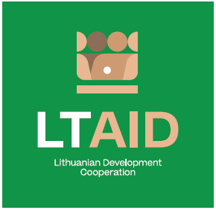
DEVELOPMENT COOPERATION PROJECT CONCEPT NO 8
“STRENGTHENING THE RESILIENCE TO DISINFORMATION IN THE EU EASTERN PARTNERSHIP COUNTRIES WHILE GIVING A SPECIAL FOCUS TO INDEPENDENT MEDIA”

GENERAL INFORMATION ON THE PROJECT
1. Partner country (-ies) | European Union’s Eastern Partnership Countries (Ukraine, Republic of Moldova, Georgia, Armenia)*
2. Area(s) of cooperation | Democracy and civil society strengthening
3. Project description
3.1. Project aim | Strengthening the resilience to disinformation and strategic communication skills, ensuring the dissemination of independent information.
3.2. Project objectives | 1. To strengthen strategic communication capabilities of the EU Eastern Partnership countries and their effective response to disinformation.  2. To strengthen the abilities and opportunities of independent media to engage in the fight against disinformation and the partnerships with civil organizations as well as build society's resistance to disinformation.  3. To empower independent media and civil organizations to systematically publicize and counter attempts to disinform the public as well as increase public awareness of the danger posed by disinformation.  4. To share Lithuania’s experience and exchange good practices among the countries involved in the project in order to strengthen independent media.
3.3. Target group(s) | Public opinion leaders of the EU Eastern Partnership countries, media and the civil society.
4. Estimated duration of project implementation | Up to 12 months, if the total cost of the project is less than 50.000 EUR.  Up to 24 months, if the total cost of the project is more than 50.000 EUR.
5. Additional information  Where available, indicate additional evaluation criteria* for project applications to be drawn up according to this project concept, or other information important to applicants. | - Experience in implementing projects of a similar nature;  - Financial contribution of applicant and / or other additional sources of financing.
*Please select no less than three countries mentioned
*According to Paragraph 35 of the Description of the Procedure for the Implementation of Development Cooperation and Humanitarian Aid Activities by State and Municipal Institutions and Agencies approved by Resolution No 278 of the Government of the Republic of Lithuania dated 26 March 2014, an application can be assigned additional scores for compliance with the additional project application evaluation criteria indicated in the institution’s call. The additional criteria may be provided for if a specific development cooperation activity is planned in the call or if specific abilities or experience are expected from the applicants

