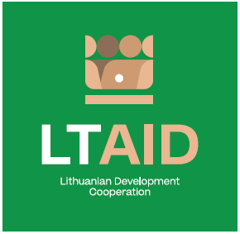
DEVELOPMENT COOPERATION PROJECT CONCEPT NO 9

“SUPPORT FOR THE STRENGTHENING OF THE ADMINISTRATIVE AND INSTITUTIONAL CAPACITy OF UKRAINE, THE REPUBLIC OF MOLDOVA AND Georgia IN THE FIELD OF EUROINTEGRATION”

GENERAL INFORMATION ON THE PROJECT
1. Partner country (-ies) | Ukraine, Republic of Moldova, Georgia*
2. Area(s) of cooperation | Good governance and the strengthening of administrative and institutional capacity
3. Project description
3.1. Project aim | To support Ukraine, the Republic of Moldova and Georgia to implement the necessary reforms in order to further integrate them into the EU.
3.2. Project objectives | To provide Lithuanian expert support to the state institutions of Ukraine, the Republic of Moldova and Georgia in order to:  1.1 . to help partner countries implement the 17 June 2022 recommendations presented in the European Commission's Communications to the European Parliament, the European Council and the Council (COM/2022/405, COM/2022/406, COM/2022/407);  1.2. to transfer the good practice of Lithuania in the field of European integration when carrying out reforms in each partner country, including the further implementation of the AA/DCFTA.
3.3. Target group(s) | State institutions of Ukraine, Republic of Moldova and Georgia.
4. Estimated duration of project implementation | Up to 12 months, if the total cost of the project is less than 50.000 EUR.  Up to 24 months, if the total cost of the project is more than 50.000 EUR.
5. Additional information  Where available, indicate additional evaluation criteria* for project applications to be drawn up according to this project concept, or other information important to applicants. | - Experience in implementing projects of a similar nature;  - Financial contribution of applicant and / or other additional sources of financing.
*Select no less than two countries mentioned
*According to Paragraph 35 of the Description of the Procedure for the Implementation of Development Cooperation and Humanitarian Aid Activities by State and Municipal Institutions and Agencies approved by Resolution No 278 of the Government of the Republic of Lithuania dated 26 March 2014, an application can be assigned additional scores for compliance with the additional project application evaluation criteria indicated in the institution’s call. The additional criteria may be provided for if a specific development cooperation activity is planned in the call or if specific abilities or experience are expected from the applicants.

